**CRM APPLICATION THAT HELPS TO BOOK A VISA SLOT** **1.INTRODUCTION** **1.1 Overview** CRM Application that helps to book a visa slot will help you to track and manage the availability of visa slots, which are appointments that are require for certain visa applications. **1.2 Purpose** It might be used by a government agency or a visa processing center to schedule and manage appointments with applicants. **2. Problem Definition & Design Thinking** **2.1 Empathy Map** 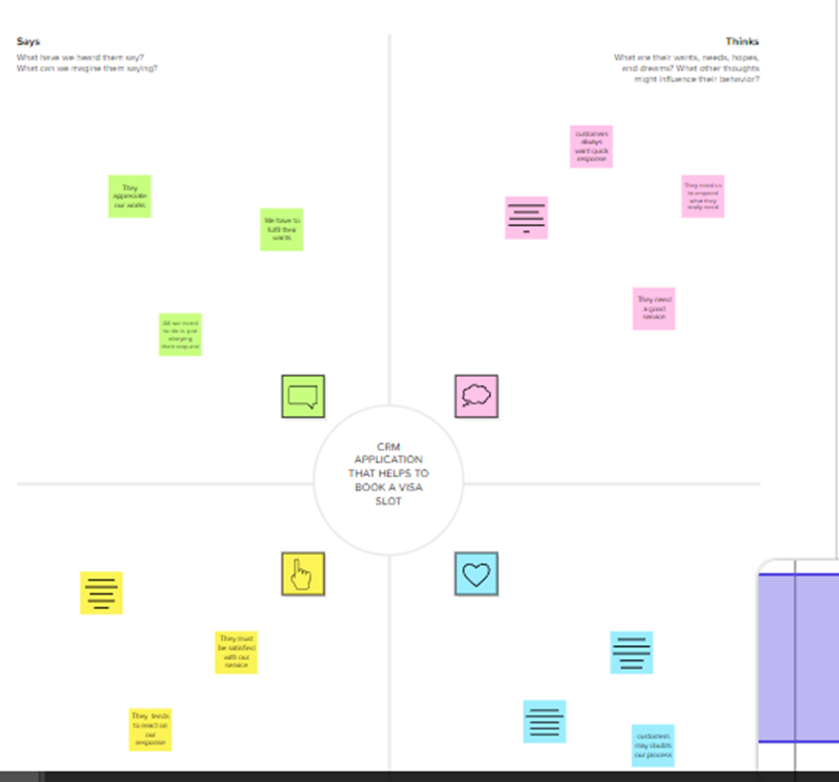

**2.2 Ideation & Brainstroming Map**

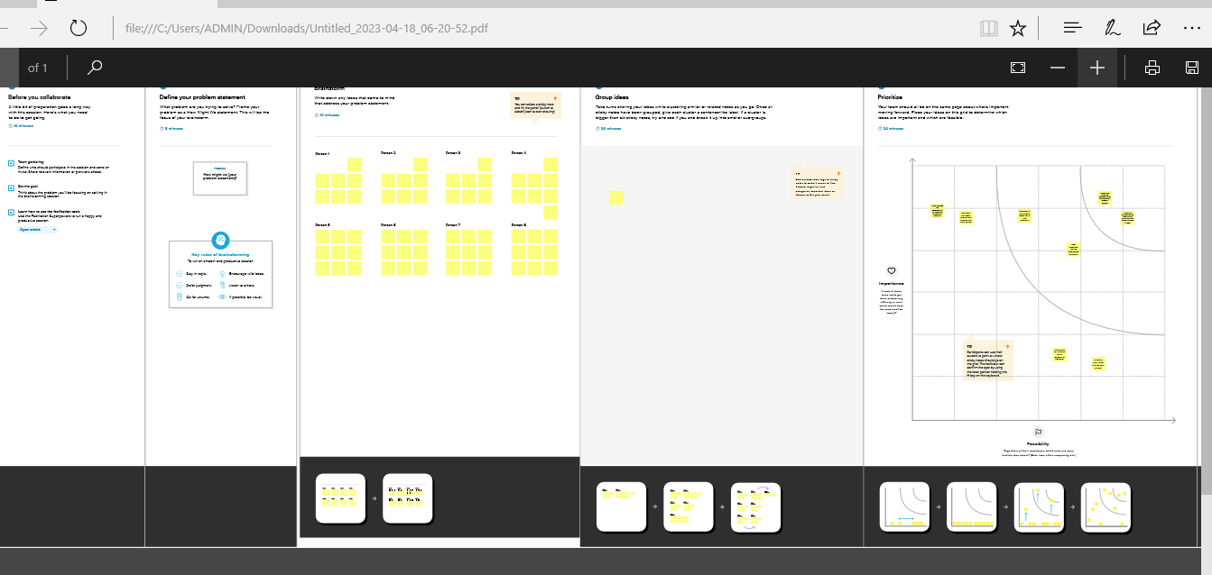

**3. RESULT** **3.1** **Data Model:**

|  |  |  |  |  |  |  |
| --- | --- | --- | --- | --- | --- | --- |
| |  |  | | --- | --- | | **Object name** | **Fields in the Object** | | Object 1 Standard Object | Standard Field | | Object 2 Customize Object | Customize Field | |

**3.2** **Activity & Screenshot** 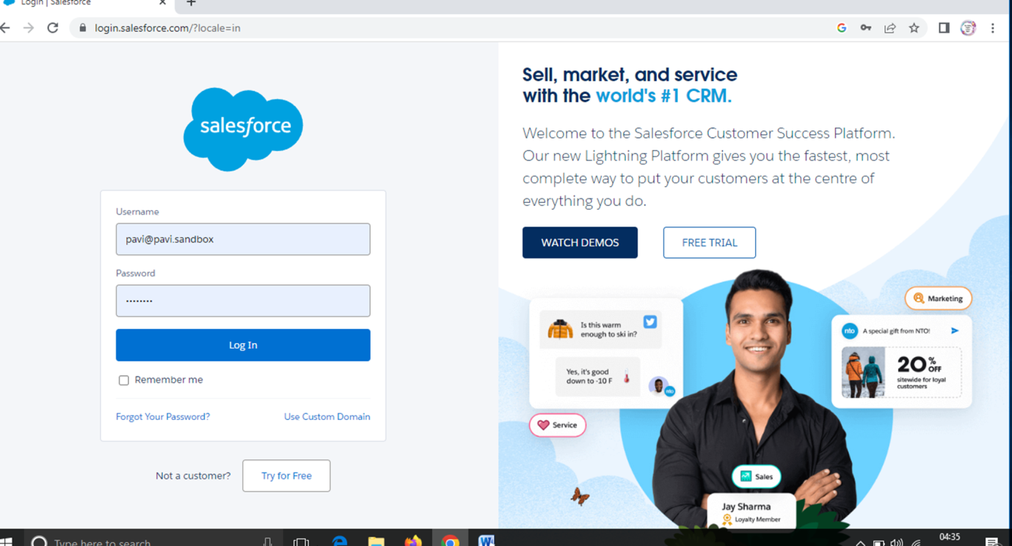 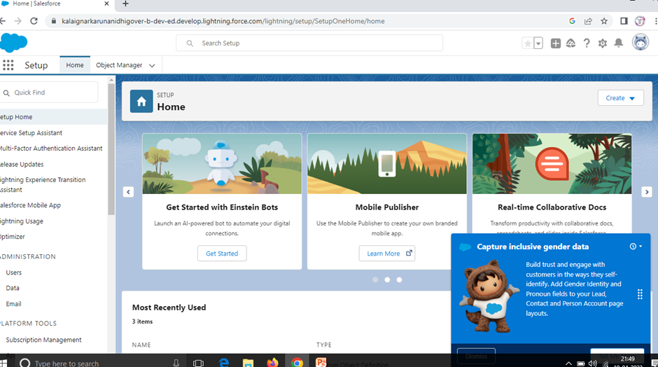

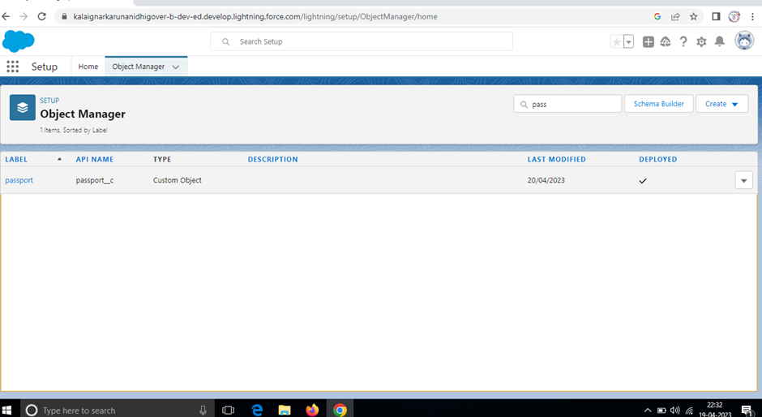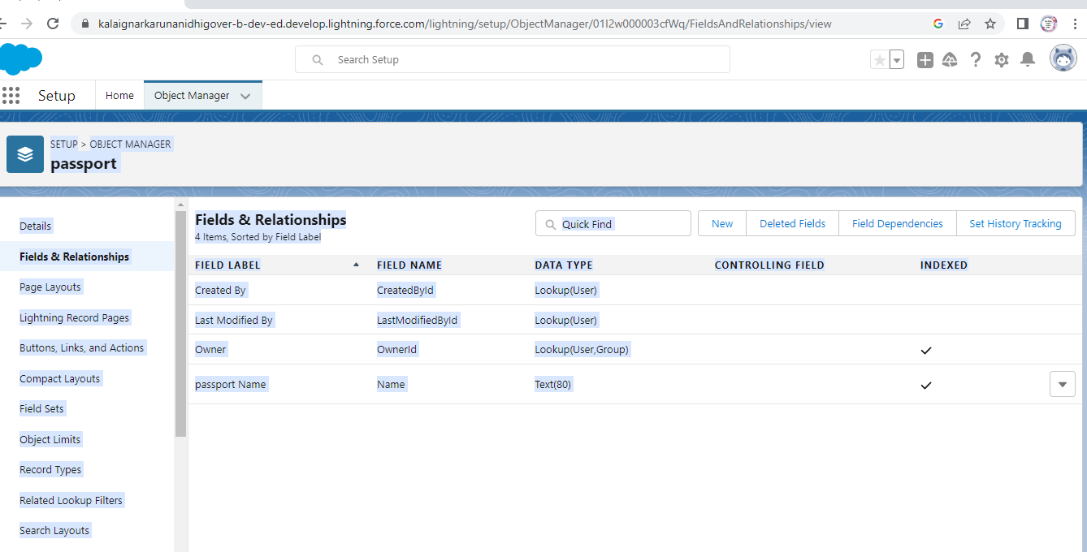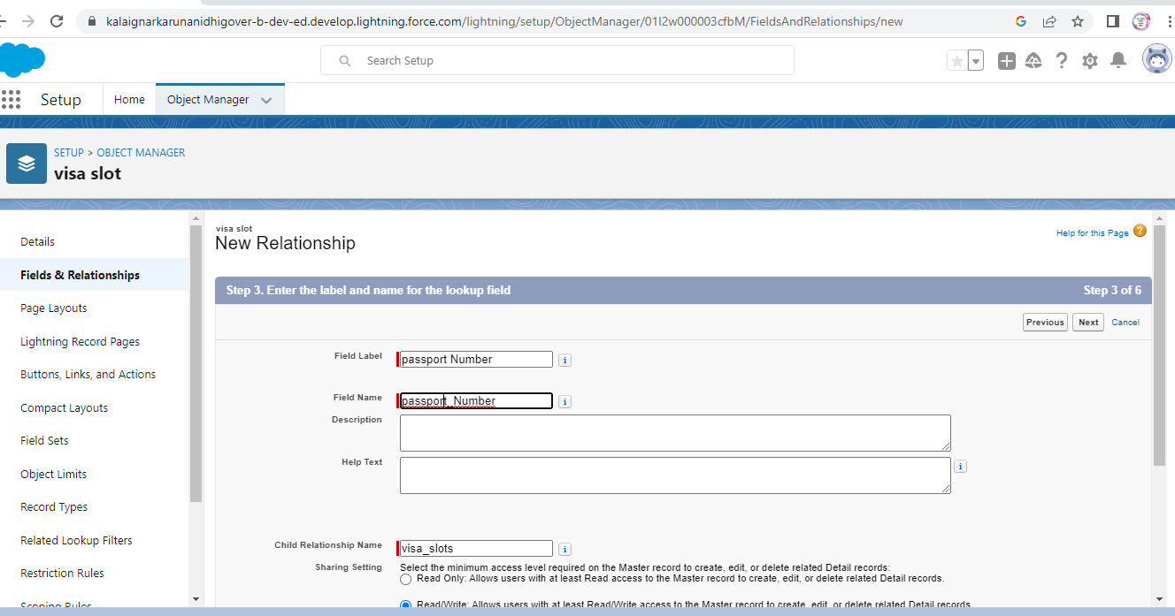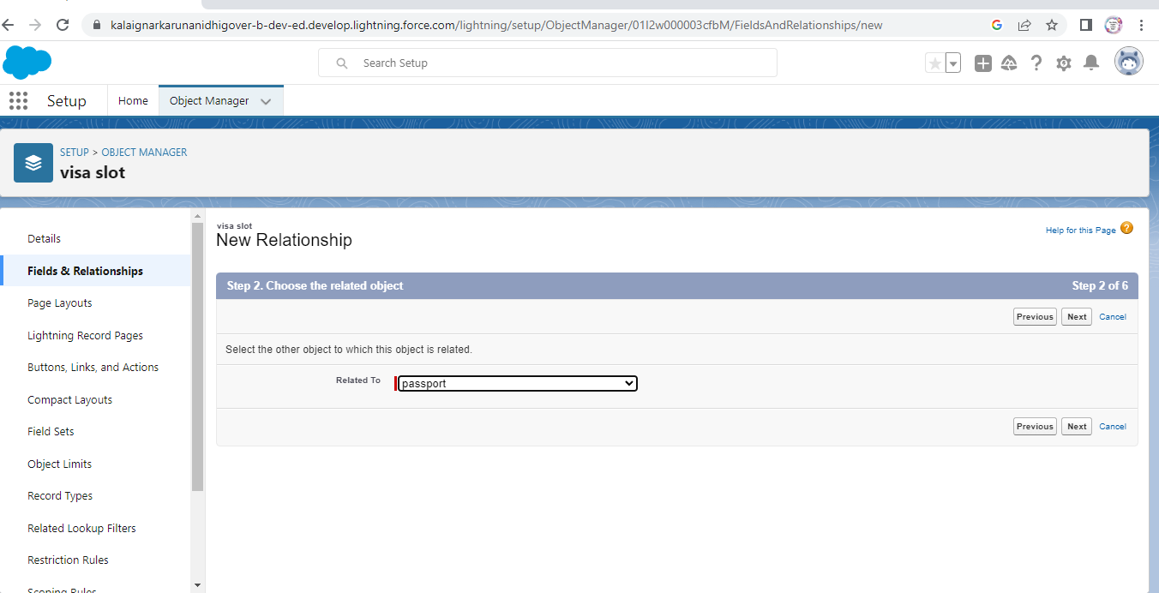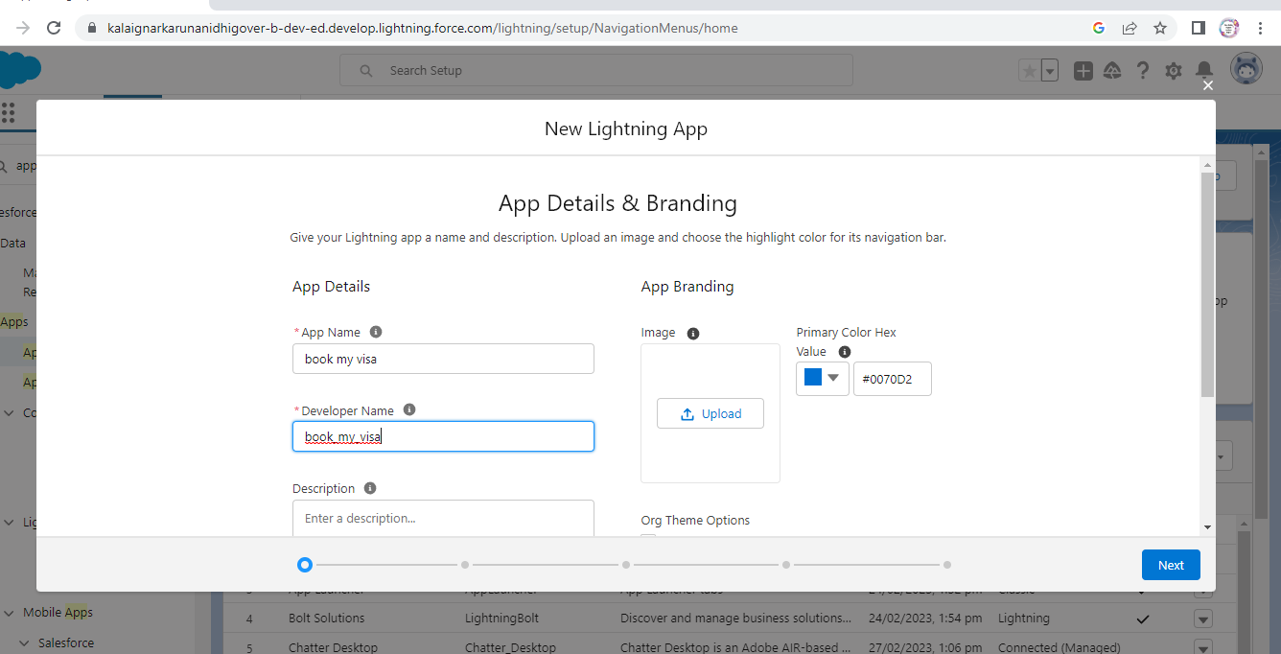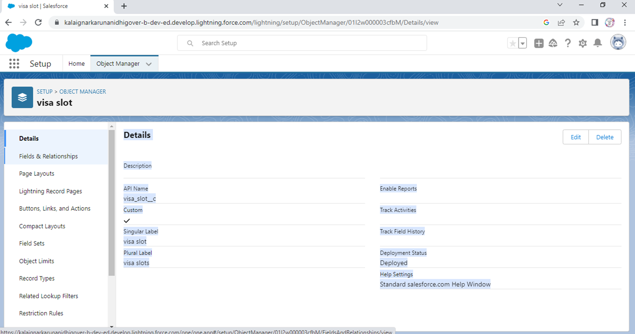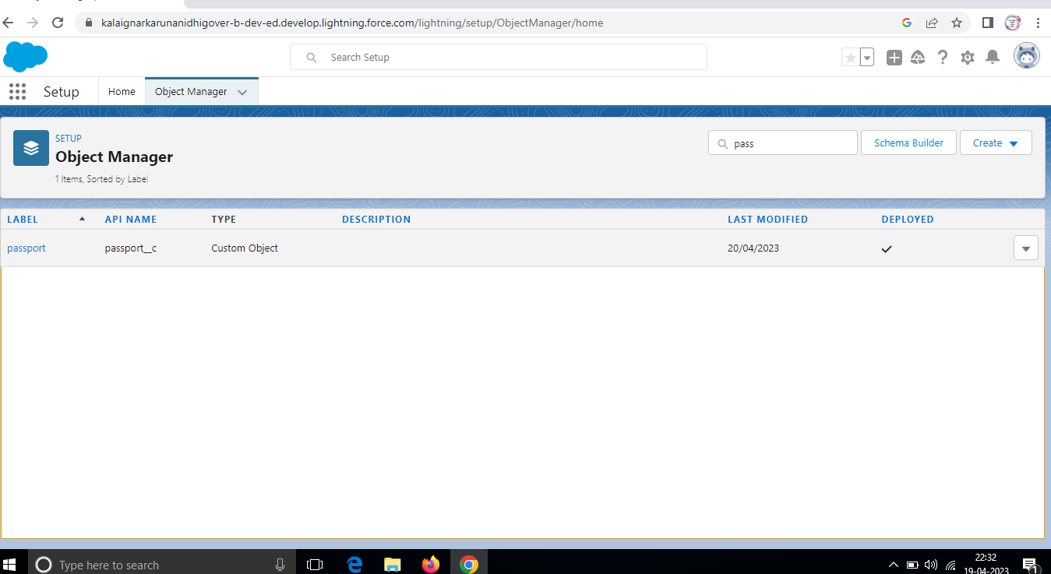

f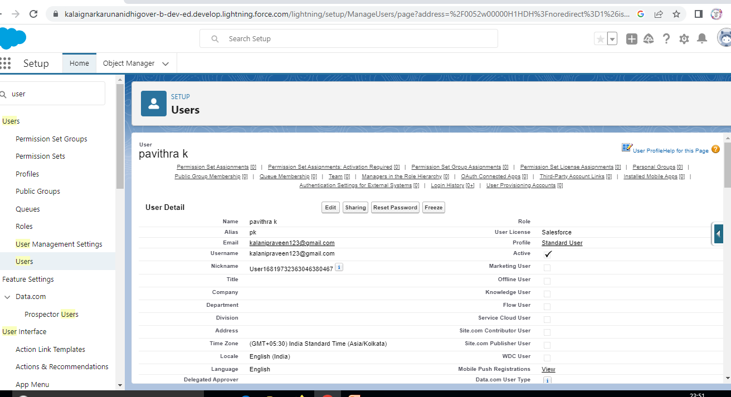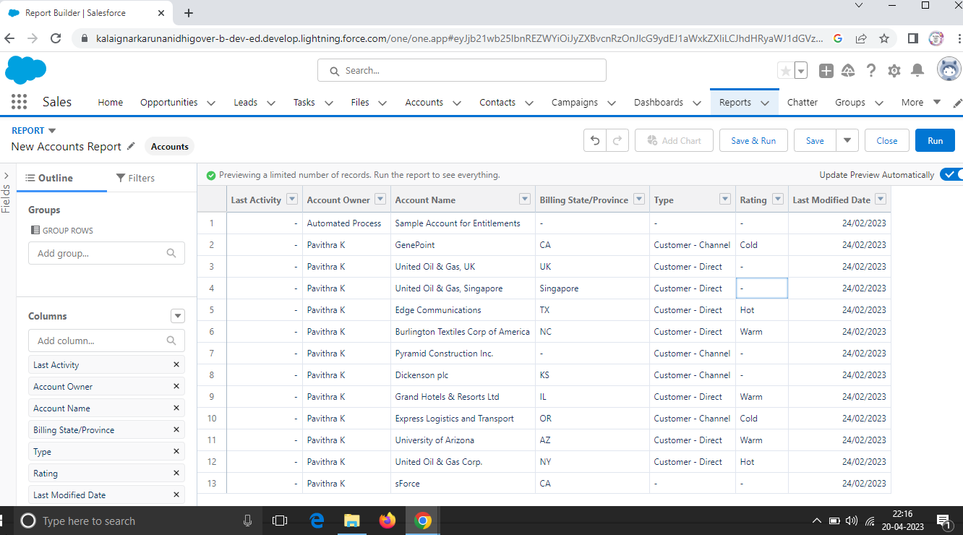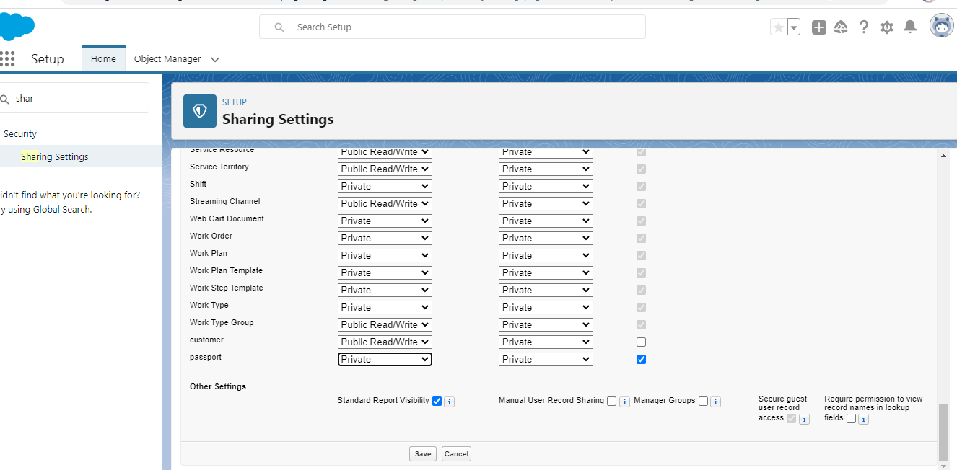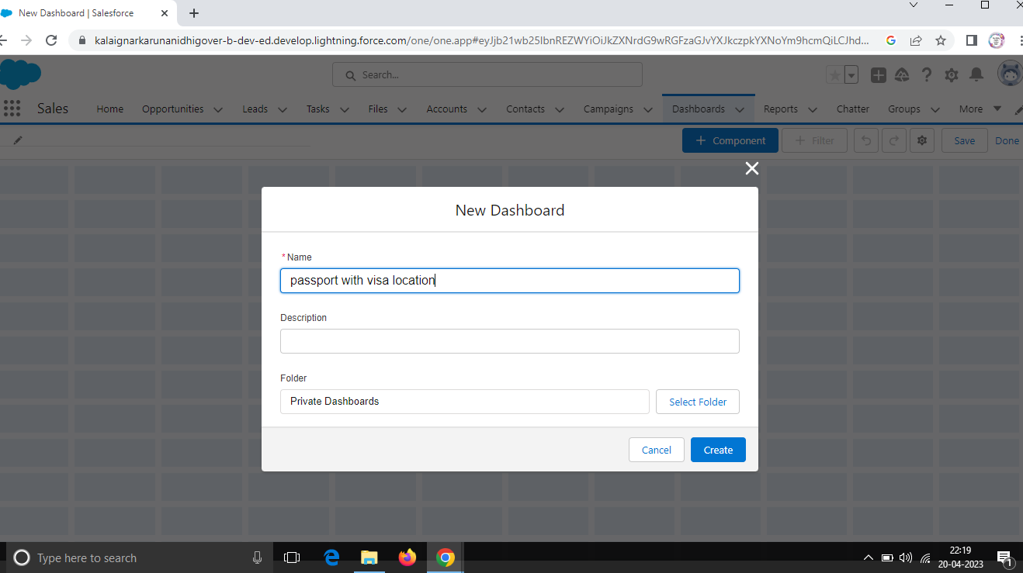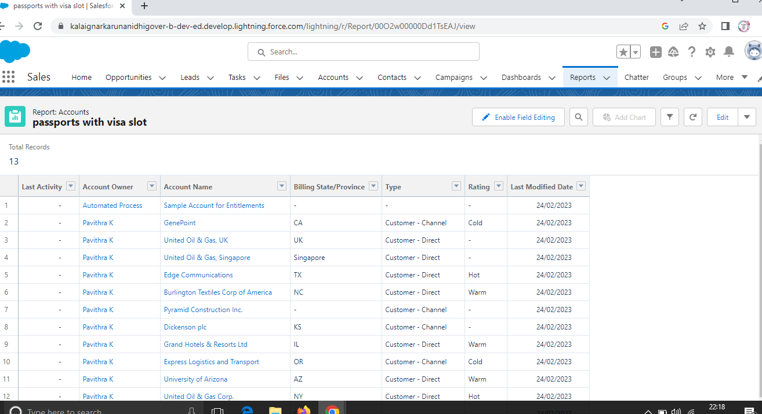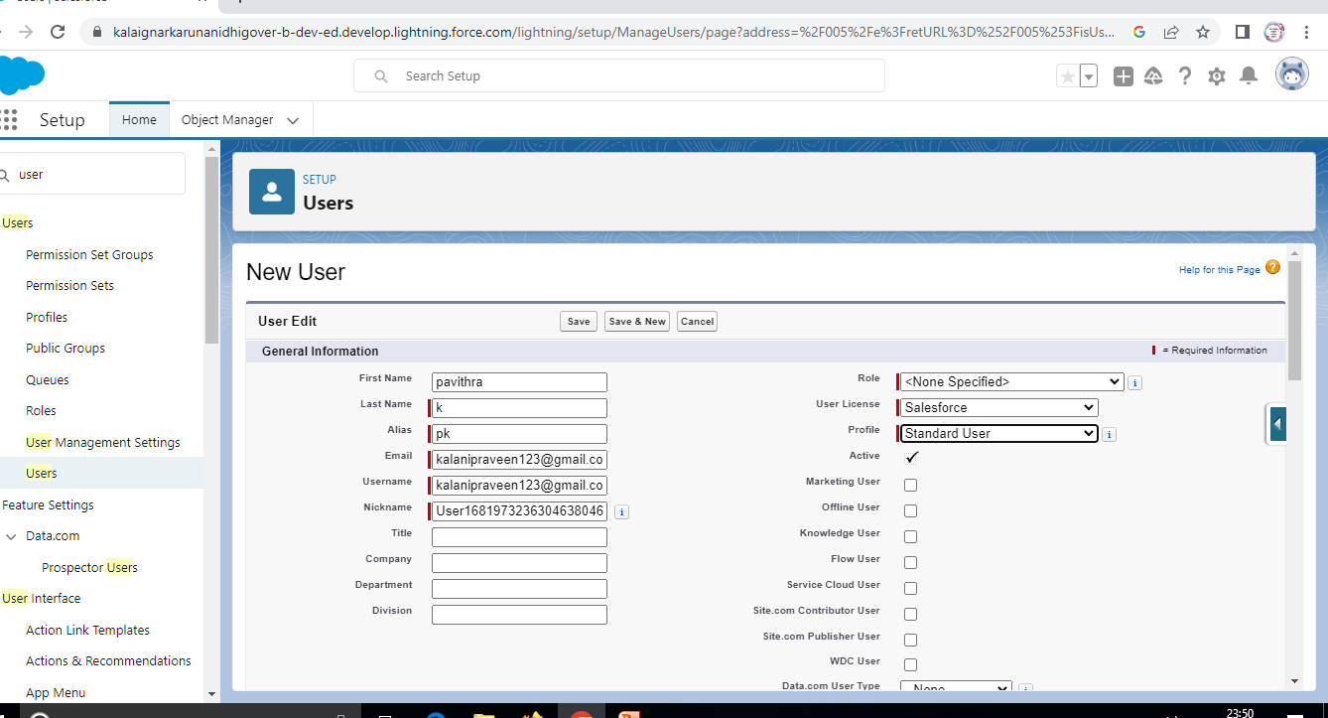

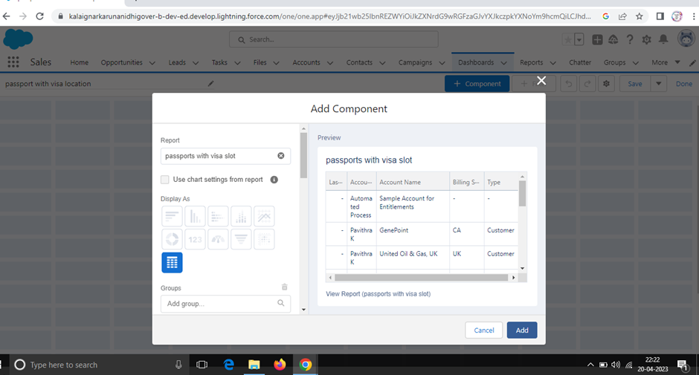

**4. Trailhead Profile Public URL** Team Lead-https://trailblazer.me/id/pavik40 Team Member1 -https://trailblazer.me/id/vlachi2 Team Member 2-https://trailblazer.me/id/sivam100 Team Member3-https://trailblazer.me/id/suba2003 **5. ADVANTAGES & DISADVANTAGES** This will helps you to track and manage the availability of visa slots, which are appointments that are required for certain visa applications. Certain businesses where customer transactions are highly standardised may not benefit from a CRM system. **6. APPLICATIONS** CRM is short for customer relationship management, and it refers to platforms and technologies that help you manage all of your customer interactions and communications. **7. CONCLUSION** The company is using various CRM Practices like customization of the product, maintaining interaction with customers regularly and providing good quality product etc. **8. FUTURE SCOPE** We can achieve with a CRM software that’s small, medium enterprises must use CRM Software. So lets know the Future Scope of Accounting Software for small and medium enterprises.